Design Brief Template

Part 1: Site plan

Draw the plantscape (see example on the following page) and include the following:

* The Client name
* A drawing title
* A north point to orient the site plan
* A key or legend that explains what the icons on the drawing indicate (for a planting drawing, the icons will most likely indicate the location of plants and different species/cultivars). Keys are also useful for indicating different zones (e.g. blue areas often indicate lakes or ponds)
* Infrastructure such as roads, pathways, access areas, buildings, powerlines, utilities (e.g. sewer lines), amenity blocks, scenic viewpoints

*Please see topic 7.1.1 for more information). Ensure that the scale is relevant to the drawing. You might find it useful to draw your design on grid paper, although this is not mandatory.*

|  |
| --- |
| **Client Name: Design Title:** |
|  |

Part 2: Concept brief

**1. Introduction**

*What is the purpose of the plant display? Why is it needed? What is the client trying to achieve? Include any other interesting information that introduces the concept, context or the site*.

<<Enter your response here>>

**2. Site considerations**

*2.1 Access*

*How will the site be accessed? Are there any factors impacting plantscaping?*

<<Enter your response here>>

2.2 Environment

*Take light meter readings for low light areas, assess drainage soil type, any other factors in regard to both plant growth (e.g. photosynthesis, nutrient uptake etc) impacts on plant suitability and any site conditions and constraints impacting plantscaping (e.g. pH levels)*

<<Enter your response here>>

2.3 Site clean up

*What will be need to be removed when work completed e.g. fencing, excess soil, equipment collection, rubbish removal etc*

<<Enter your response here>>

2.3 Other

*Based on your initial impressions of the environment what are likely pests and diseases you need to be aware of in terms of plant selection? What types of plants should be avoided?*

<<Enter your response here>>

**3. Plant selection**

*Complete the following table for at least 5 species of plants. Add photo or drawing (optional)*

|  |  |  |  |  |
| --- | --- | --- | --- | --- |
| **Common name** | **Scientific name** | **Description/notable features** | **Any special requirements for planting/maintenance** | **Number of plants** |
| *Lomandra* | *Lomandra longifolia* | *Perennial, rhizomatous herb found throughout eastern Australia. The leaves are 40 cm to 80 cm long, and generally have a leaf of about 8 mm to 12 mm wide* | *Do not plant too close to waterways as tend to clump or pathways due to spiky leaves. Require little maintenance when established.* | *20* |
|  |  |  |  |  |
|  |  |  |  |  |

**4. Other resources**

4.1 Materials and equipment

*Identify the materials, equipment and PPE required.*

<<Enter your response here>>

4.2 Personnel

*Identify the personnel required.*

<<Enter your response here>>

**5. Landscaping**

5.1 Topography

*Describe the current and modified lay of the land. Drawing is optional.*

<<Enter your response here>>

5.2 Substrate

*Will mulch be used, bare earth, lawn, paved hardscapes, clearings etc. In the case of new substrate such as sand and mulch; how much needs to be ordered?*

<<Enter your response here>>

5.3 Drainage

*Describe drainage requirements.*

<<Enter your response here>>

5.3 Other requirements

*Does the planting relate to paving, fencing or other structures, do the plants need protection from animals? Do the plants need securing – e.g. are stakes, trellises etc required?*

<<Enter your response here>>

**6. Service requirements**

6.1 Plant care

*Will the plants need acclimatizing? If so, how will this be done? What plants and substrate will require periodical replacement? What plants will need pruning?*

<<Enter your response here>>

6.2 Watering

*Describe watering requirements and how all surfaces and plants can be reached for cleaning and watering.*

<<Enter your response here>>

6.3 Pest control

*List any pests that might affect the selected plants, describe how to prevent and treat the pests. Also include any vertebrate pests that may be attracted to fruit or flowers of the plants.*

<<Enter your response here>>

6.4 Ongoing maintenance

*What else can be done to enhance the appearance of plants and maintain in good health?*

<<Enter your response here>>

Part 3: Risk Assessment

In order to ensure a safe work environment, you need to complete a risk assessment of the site. Complete the following steps and complete the Table below:

**Step 1:** Conduct a site inspection and note any hazards (maximum three)

**Step 2:** What risks are associated with the hazard?

**Step 3:** How significant are these risks? Use the ‘Risk-rating Matrix’ below to assign a risk rating to each based on the likelihood and the consequence of each risk?

**Step 4:** Use the ‘Hierarchy of Control’ below to decide on how the hazard can be controlled.

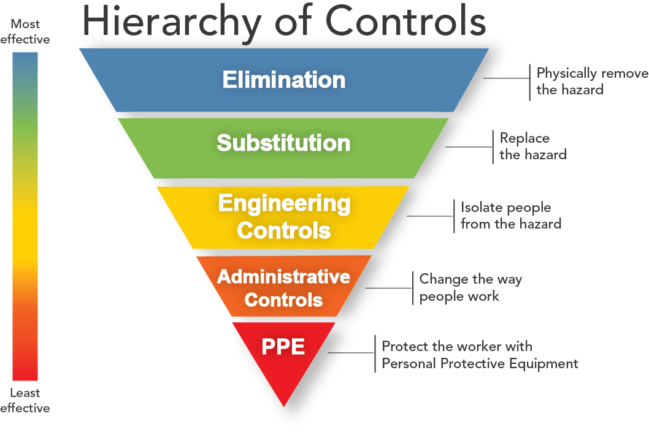

**Step 5:** Complete the table below.

|  |  |  |  |
| --- | --- | --- | --- |
| **Hazard** | **Risk** | **Risk rating** | **Control measure** |
|  |  |  |  |
|  |  |  |  |
|  |  |  |  |